Name: ________________
Date: _______________

Renaissance Philosophy - “Pathways” textbook
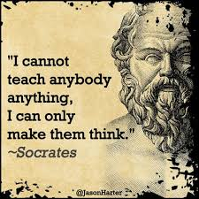

Humanism  Read the quotation on p.208, and the section on Humanists (p.222-23).  - What ideas were important to the Humanists? | How was Humanism different from Medieval attitudes?

Petrarch
Read Petrarch’s Letter to You (p.222).
- List three ideas important to Petrarch.

1)

2)

3)

Machiavelli
Read selections from The Prince (p.223)
- Summarize his advice to a ruler.

- Why does he feels this is needed to rule effectively?

Savonarola
- What are his criticisms of society?

- What happened to him?

- What were the “bonfire of the vanities”?

Modern Day Renaissance Thinkers

Group discussion: 1x person will be the note-taker, the others will be the speakers
Petrarch
- How would you live your life on a daily basis in Vancouver?

- As a “Renaissance man”, or “Renaissance woman” today, what areas would you need to be skilled in?

- What subjects would you find most worthwhile to study?

- How would you view your own generation?

Machiavelli
- How would you run Prince of Wales Secondary following Machiavelli’s principles?

- How would you deal with those who set garbage cans on fire? Those who are late for class?

- Would there be hope for PW students to improve themselves through their own efforts?

Savonarola
- Make a list of items from modern culture that you would want to throw onto a modern day “bonfire of the vanities”. Explain how each item represents an abuse.

