World Indigenous Civilizations Webpage

Big Ideas:

Content: Social, political, and economic systems and structures, including those of at least one indigenous civilization.

Part 1 – Learning about an indigenous civilization.

Task:
- Create a webpage that summarizes the political, economic, religious, social, intellectual, and artistic systems and structures (PERSIA) of an indigenous civilization pre-contact.
- Your webpage must provide an overview of the following:
  - A front page with sections on:
    - An historical overview (how old is this civilization, significant events, etc).
    - Where the culture was located (description plus map).
    - An embedded video or audio file that helps to explain more about the civilization.
- Sub-pages:
  - Provide an overview of an aspect of the culture (one of PERSIA).
  - Address the key questions that relates to your aspect of culture.
  - Include a gallery of images or other media that supports the text you include.
Options:
Select one of the following aspects of the society; and one additional responsibility:

Aspect of culture to research (choose one): | Key Question | Additional responsibility – front page (choose one):
Social | What was the status of women? (Social) | Webmaster (layout of front page)
Political | How were political decisions made during this period 7th -1750? | Historical overview of culture
Economic | How was wealth distributed in the culture? | Description of location & map
Religion | What were the main beliefs of society? (Religious) | Select a video to introduce the culture
Intellectual or Artistic | How did this society express itself artistically? | Description of settlements/architectural style

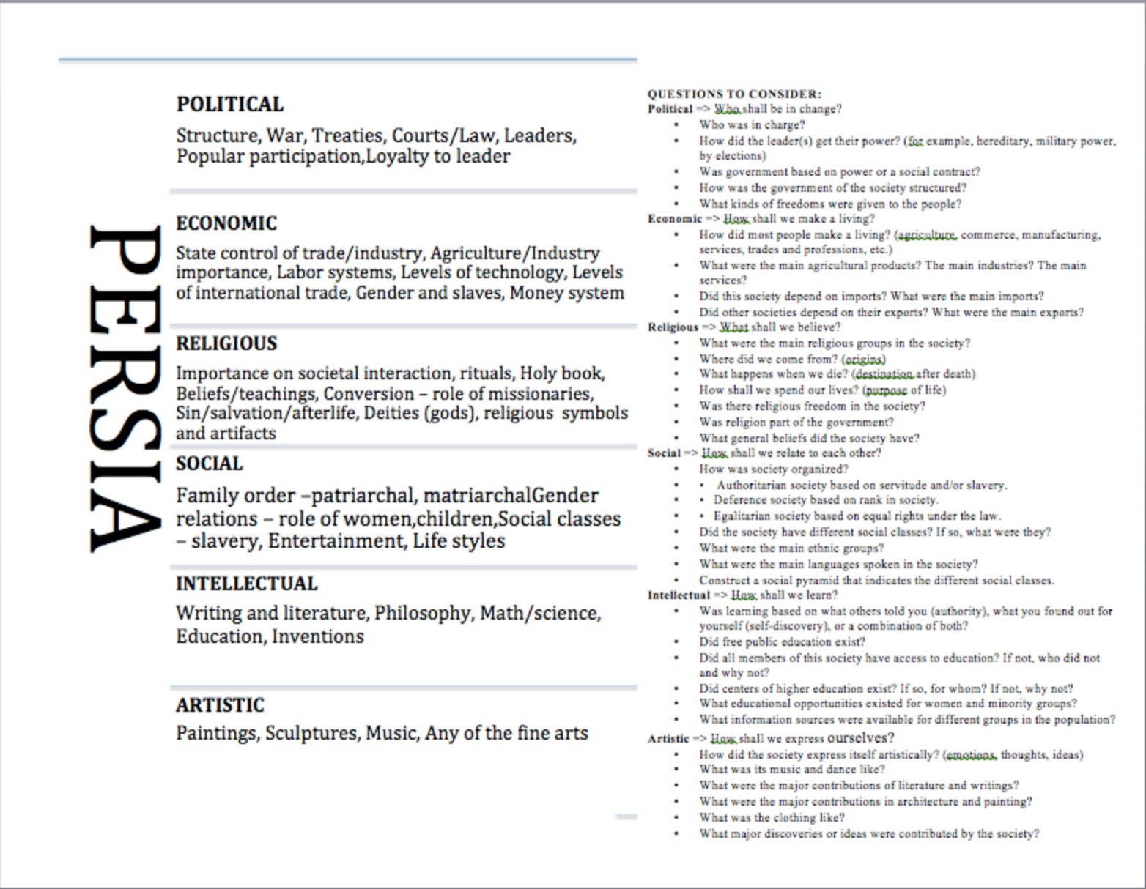

Assessment
Please see the next page.

Part 2 – Examining the effects of the arrival of settlers.

Task:
- Create a new section on your webpage that answers both of the key questions below.
- Your answers should be directly related to the aspect of culture you have already researched.
- Include an introduction that provides a brief overview of contact.
- Include images, graphs, charts, tables or other media that supports your text.

Aspect of culture to research: | Key Questions  (answer both) | Additional info to be included
Social | What changes occurred as a result of contact and conflict?  What consequences resulted from exploration, expansion, and colonization? | An introduction including:  - Who made contact?  - When contact occurred?  - Which country(ies) explored/expanded/colonized in the traditional territory of the indigenous group you are researching?  A conclusion that summarizes the impacts and/or effects of colonization.
Political
Economic
Religion
Intellectual or Artistic

Part 3 – Determining significance
- Working with another group, complete a Venn diagram that identifies similarities and differences between both indigenous cultures.
- How significant were the changes and consequences of exploration and colonization on the groups of people involved?
  - Use the criteria to determine significance in your reply:
    - Number of people impacted
    - Impact on people’s lives
    - Resulted in long-lasting change
    - Part of a larger historical trend

- Select four different changes/consequences that occurred.
- Rank these in terms of their significance from most to least.

Assessment – Proficiency Rubric

Curricular competency | Emerging | Developing | Proficient | Extending
Change and Continuity | Can identify that things changed amongst a culture | Can identify and briefly state how things changed amongst a culture | Can identify and describe what changed, and what remained the same for people of a culture | Can identify and describe an overview of what changed and remained the same for people of a culture that links to causes and consequences
Cause and Consequences | Provides inaccurate or unspecific factors that led to the event and its’ consequences | Provides limited, vague or non-specific factors that led to the key event and its’ consequences | Provides accurate factors that lead to the key event and its’ consequences. | Provides detailed and accurate factors that led to the key event and has offered multiple consequences for various groups effected
Significance | Includes an event, concept, or person (element) that relates to the topic | Selects elements that are related to the topic  Expresses an opinion about the significance of an event, concept, or person | Selects elements that are all historically significant  Can argue why and element should be considered significant using one criterion | Selects elements that are all historically significant  Accurately uses various criteria for judging the significance of each element
Communication | Can display elements in a random order | Can provide and explain some organization of the elements in the layout | Can determine the most effective way of communicating information and sharing ideas  Can communicate using the most appropriate or effective form, including images, text, speech, and media. | Can determine the most effective way of communicating ideas and defend the logic of an appropriate and well-planned layout

