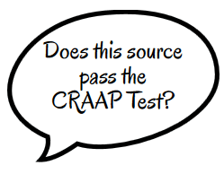CRAAP Analysis: Innovations
Currency, Reliability, Authority, Accuracy, Purpose (CRAAP)

- For the various websites you use in your research notes, explain how that source is reliable and unreliable (point form). It should have a minimum of 3 points to justify its reliability, if you are in fact using it!
- Use your yellow CRAAP rubric for each source, and provide an overall score out of 4.
- In point form, list the most important examples to support reliability/unreliability.
- You will submit this with your research notes before spring break.

- Website URL:

What makes the website seem reliable | What makes this website seem unreliable?

Overall Score: o

- Website URL:

What makes the website seem reliable | What makes this website seem unreliable?
Overall Score: o

- Website URL:

What makes the website seem reliable | What makes this website seem unreliable?
Overall Score: o

