World Indigenous Civilizations Webpage

Big Ideas:

Content: Social, political, and economic systems and structures, including those of at least one indigenous civilization.

Task:
- Create a webpage that summarizes the social, political, economic and religious systems and structures (SPER) of an indigenous civilization.
- Your webpage must provide an overview of the following:
  - A front page with sections on:
    - An historical overview (how old is this civilization, significant events, etc).
    - Where the culture was located (description plus map).
    - An embedded video or audio file that helps to explain more about the civilization.
- Sub-pages:
  - Provide an overview of an aspect of the culture (one of SPER).
  - Address the key questions that relates to your aspect of culture.
  - Include a gallery of images or other media that supports the text you include.
Options:
Select one of the following aspects of the society; and one additional responsibility:

Aspect of culture to research (choose one): | Key Question | Additional responsibility – front page (choose one):
Social | What was the status of women? (Social) | Webmaster (layout of front page)
Political | How were political decisions made during this period 7th -1750? | Historical overview of culture
Economic | How was wealth distributed in the culture? | Description of location & map
Religion | What were the main beliefs of society? (Religious) | Select a video to introduce the culture
Intellectual or Artistic | How did this society express itself artistically? | Description of settlements/architectural style

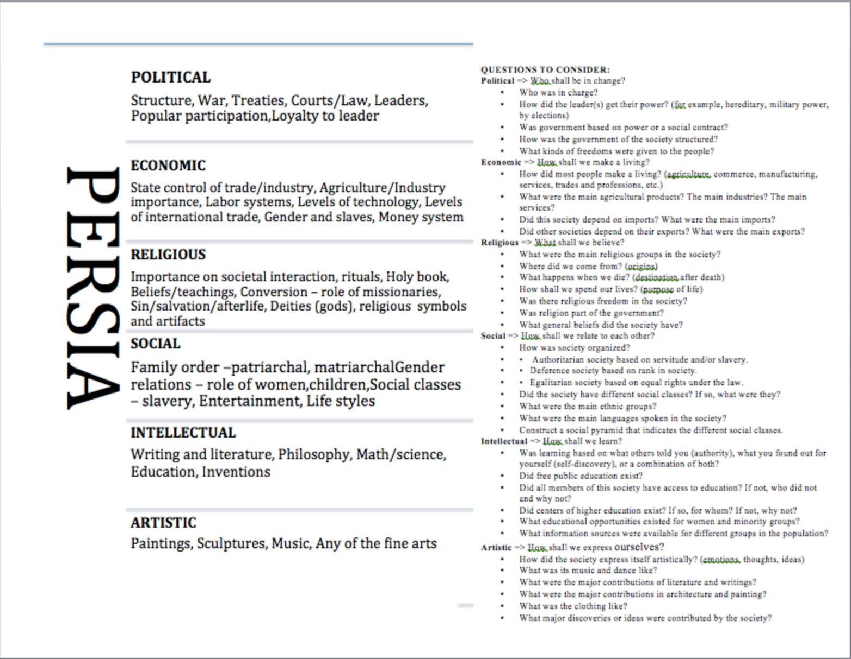

Assessment
Please see the next page.

Single Point Rubric for Indigenous Cultures Website

Developing  Areas that need development | Applying  Standards for this performance | Extending  Evidence of exceeding standards
 | Uses Social Studies inquiry processes and skills to ask questions; gather, interpret, and analyze ideas and data; and communicate findings and decisions.
Significance
Assess the significance of people, places, events, or developments at particular times and places.
Quality of webpage
- Webpage is well constructed and is visually appealing.
- Use of color, graphics, shapes, etc. enhance presentation.
- Good use of space.
Works Cited
Minimum number of sources are documented properly using MLA 8.
Developing (I, C-, C, C+) | Applying (B) | Exceeding (A)

