Post-Contact Indigenous Web Page Organizer

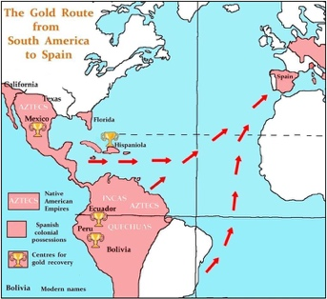 Visual(s) to support your topic. 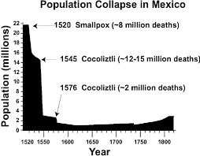
- Briefly describe the image

Intro:
- Who made contact?
- When contact occurred?
- Which country(ies) explored/expanded/colonized in the traditional territory of the indigenous group you are researching?

What changes occurred as a result of contact and conflict? (describe and explain)

What consequences resulted from exploration, expansion, and colonization?

Conclusion: Summarize the impacts and/or effects of colonization.

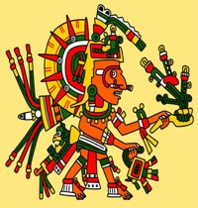 ------------ Visual(s) to support your topic
            - Briefly describe the image

