The Great Migration Letter Home

Curricular Competencies- Historical Perspective: beliefs, values, worldviews of a time period

Read the role card you have been given very carefully. You might need to research your religion and the circumstances in your country of origin. Write about your experiences during your journey to Upper Canada in a diary format. Look for clues about where you’ve come from and who has come with you. (Use stations activity, in-class notes, Horizons textbook p.23-25 and handouts).

- Use the chart on the other side as your outline. You will hand this in with your completed assignment.
- The letter must read as a real letter, make it realistic. Tell me about your family members (give them names), and the things you value in life.
- Be sure to include a personal response and sense of emotion
(eg., Do you miss home? What do you miss? The people, the place, the smells, the food?)
- Is your diary authentic? Does it read like a real diary from that time? (consider your audience). Does it look like a diary from the early 1800’s?
- Use your creativity and imagination in your response (not all “answers” to the questions below will be found in the stations or textbook. Use your creative thinking skills )
- We will take some liberties: we will assume that you can write, even though your character might be illiterate.
- Have fun and be creative
Self- Assess: Circle the letter grade that best represents your performance in pencil.
Ms.Maley will assess your work in coloured pen/highlighter.

Emerging ( I / C- ) | Developing (C / C+) | Proficient (B) | Extending/Mastery (A)
Does not demonstrate basic understanding of concepts or competency of skills. Many items are missing or incomplete. | Demonstrates a basic understanding of concepts. Some items are missing or incomplete | Demonstrates a solid understanding of concepts and criteria. | Demonstrates a complete and sophisticated understanding of concepts.

Great Migration: Historical Thinking – Historical Perspective

I’m still working on…  (C-/C/C+)  Demonstrates an initial or basic/partial understanding of the concepts Some items are missing or incomplete. | I can… | I did it…  (B-, B, B+, A)  Demonstrates a solid/complete , or sophisticated understanding of concepts and criteria.
Emerging/Developing | … make inferences (come to a creative and realistic conclusion) about the perspective of a person or group from the evidence I have. | Proficient/Outstanding
Emerging/Developing | … identify the values, beliefs, and practices of a time period  (feelings, motivations, reactions, what mattered and didn’t matter) | Proficient/Outstanding
Emerging/Developing | … successfully use evidence to support a historical perspective | Proficient/Outstanding

Student Assessment Overall: C- , C, C+, B-, B, B+, A (circle)
Strengths
Reflection:
Growth

Plan for Growth:

Teacher Assessment: C- , C, C+, B-, B, B+, A (circle)

Comments:

Settler Chart Concepts/Criteria: this will act as your rough copy for the letter home
(submit this with good copy letter)

Name

Country of Origin
How does this impact your life?
Religion
How does religion impact your life?
Describe your family members

Describe your life before coming to Upper Canada
- Wealth?
- Skills/education?
- Opportunities?
Push and Pull factors that caused you to move to Canada? | Push:  Pull:
How did you get to Upper Canada?

Describe the Journey

Hopes & Dreams for your new life and new land?

Fears/Concerns?

Are you ready for the challenges ahead? How well equipped are you? Do you have enough resources?

Describe your plot(s) of land

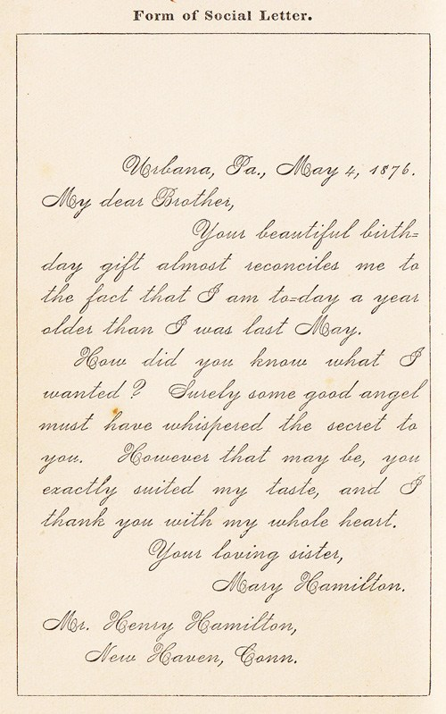

Source: https://www.google.com/search?q=victorian+letter+examples&tbm=isch&safe=strict&safe=strict&hl=en&ved=2ahUKEwiCoYnuqrvnAhUOtJ4KHWMuApMQrNwCegQIARA1&biw=988&bih=585#imgrc=UIFTwHZhRuYyxM

